Лабораторна робота №1
Написання автоматизованих тестів з використанням
мови Gherkin та Python
Лістинг 1.1 cart_steps.py
from behave import given, when, then
from eshop import Product, ShoppingCart, Order
@given("The product has availability of {availability}")
def step_impl(context, availability):
context.product = Product("Test", 100, int(availability))
@given("An empty shopping cart")
def step_impl(context):
context.cart = ShoppingCart()
@when("I add product to the cart in amount {amount}")
def step_impl(context, amount):
try:
context.cart.add_product(context.product, int(amount))
context.status = True
except:
context.status = False
@when('I try to add {val} amount')
def step_impl(context, val):
try:
# Обробка тексту "None" або рядка "text"
actual_val = None if val == "None" else val
context.cart.add_product(context.product, actual_val)
context.status = True
except:
context.status = False
@then("Product is added to the cart successfully")
def step_impl(context):
assert context.status is True
@then("Product is not added to cart successfully")
@then("System should handle error")
def step_impl(context):
assert context.status is False
@given("A cart with price {price} and {amount} items")
def step_impl(context, price, amount):
context.cart = ShoppingCart()
p = Product("Item", int(price), 100)
context.cart.add_product(p, int(amount))
@then("Total price should be {total}")
def step_impl(context, total):
assert context.cart.calculate_total() == int(total)
@given('The product "{name}" has availability {stock}')
def step_impl(context, name, stock):
context.product = Product(name, 100, int(stock))
@when('I add product "{name}" to the cart in amount {amount}')
def step_impl(context, name, amount):
context.cart.add_product(context.product, int(amount))
@when("I place an order")
def step_impl(context):
Order(context.cart).place_order()
@then('Product "{name}" should have availability {count}')
def step_impl(context, name, count):
assert context.product.available_amount == int(count)
@given("A cart with a product")
def step_impl(context):
context.cart = ShoppingCart()
context.product = Product("X", 10, 10)
context.cart.add_product(context.product, 1)
@when("I remove that product")
def step_impl(context):
context.cart.remove_product(context.product)
@then("The cart should be empty")
def step_impl(context):
assert len(context.cart.products) == 0

Лістинг 1.2 eshop.py
class Product:
def __init__(self, name, price, available_amount):
self.name = name
self.price = price
self.available_amount = available_amount
def is_available(self, requested_amount):
try:
return self.available_amount >= int(requested_amount)
except:
return False
def buy(self, requested_amount):
self.available_amount -= requested_amount
def __eq__(self, other):
return self.name == other.name
def __hash__(self):
return hash(self.name)
def __str__(self):
return self.name
class ShoppingCart:
def __init__(self):
self.products = dict()
def calculate_total(self):
return sum([p.price * count for p, count in self.products.items()])
def add_product(self, product, amount):
if amount is None or not isinstance(amount, int) or amount < 0:
raise ValueError("Invalid amount")
if not product.is_available(amount):
raise ValueError("Not enough stock")
self.products[product] = amount
def remove_product(self, product):
if product in self.products:
del self.products[product]
def submit_cart_order(self):
for product, count in self.products.items():
product.buy(count)
self.products = dict()
class Order:
def __init__(self, cart):
self.cart = cart
def place_order(self):
self.cart.submit_cart_order()

Лістинг 1.3 cart.feature
Feature: Shopping cart and Order validation
Scenario: Add exact available amount
Given The product has availability of 10
And An empty shopping cart
When I add product to the cart in amount 10
Then Product is added to the cart successfully
Scenario: Add more than available
Given The product has availability of 10
And An empty shopping cart
When I add product to the cart in amount 11
Then Product is not added to cart successfully
Scenario: Add negative amount
Given The product has availability of 10
And An empty shopping cart
When I add product to the cart in amount -1
Then Product is not added to cart successfully
Scenario: Add zero amount
Given The product has availability of 5
And An empty shopping cart
When I add product to the cart in amount 0
Then Product is added to the cart successfully
Scenario: Add None instead of amount
Given The product has availability of 10
And An empty shopping cart
When I try to add None amount
Then System should handle error
Scenario: Add string instead of amount
Given The product has availability of 10
And An empty shopping cart
When I try to add "text" amount
Then System should handle error
Scenario: Calculate total for multiple items
Given A cart with price 100 and 2 items
Then Total price should be 200
Scenario: Successful order reduces stock
Given The product "Phone" has availability 5
And An empty shopping cart
When I add product "Phone" to the cart in amount 1
And I place an order
Then Product "Phone" should have availability 4
Scenario: Remove product from cart
Given A cart with a product
When I remove that product
Then The cart should be empty
Scenario: Clear cart after order
Given A cart with a product
When I place an order
Then The cart should be empty

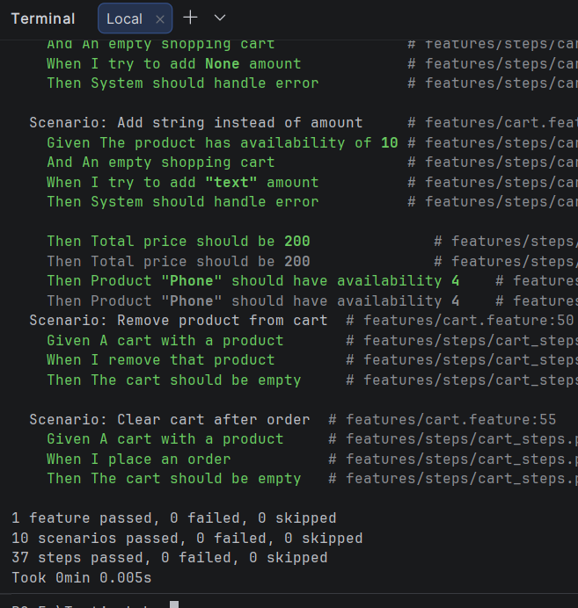
Рисунок 1 – Результат виконання тестів
Висновок: У ході виконання лабораторної роботи було опановано практичні навички автоматизованого тестування програмного забезпечення з використанням підходу BDD (Behavior-Driven Development).

